GIT configuration and hosting a web page under Load balancer on two diff region.

Architecture:

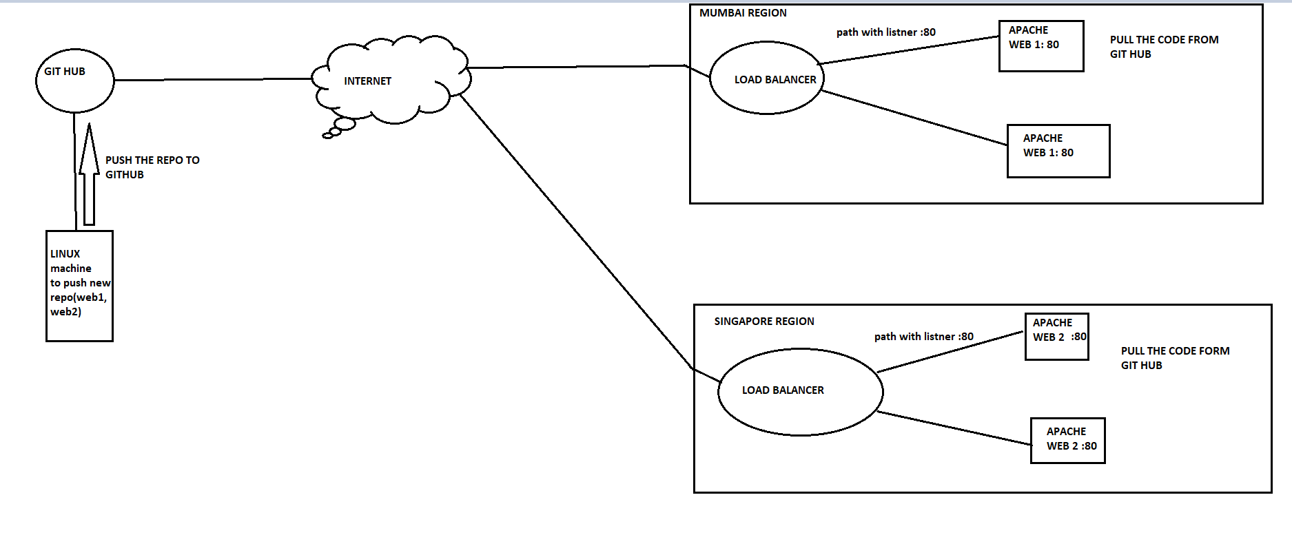

Create a vpc with two az for public subnet under two region (Mumbai and Singapore):

MUMBAI:

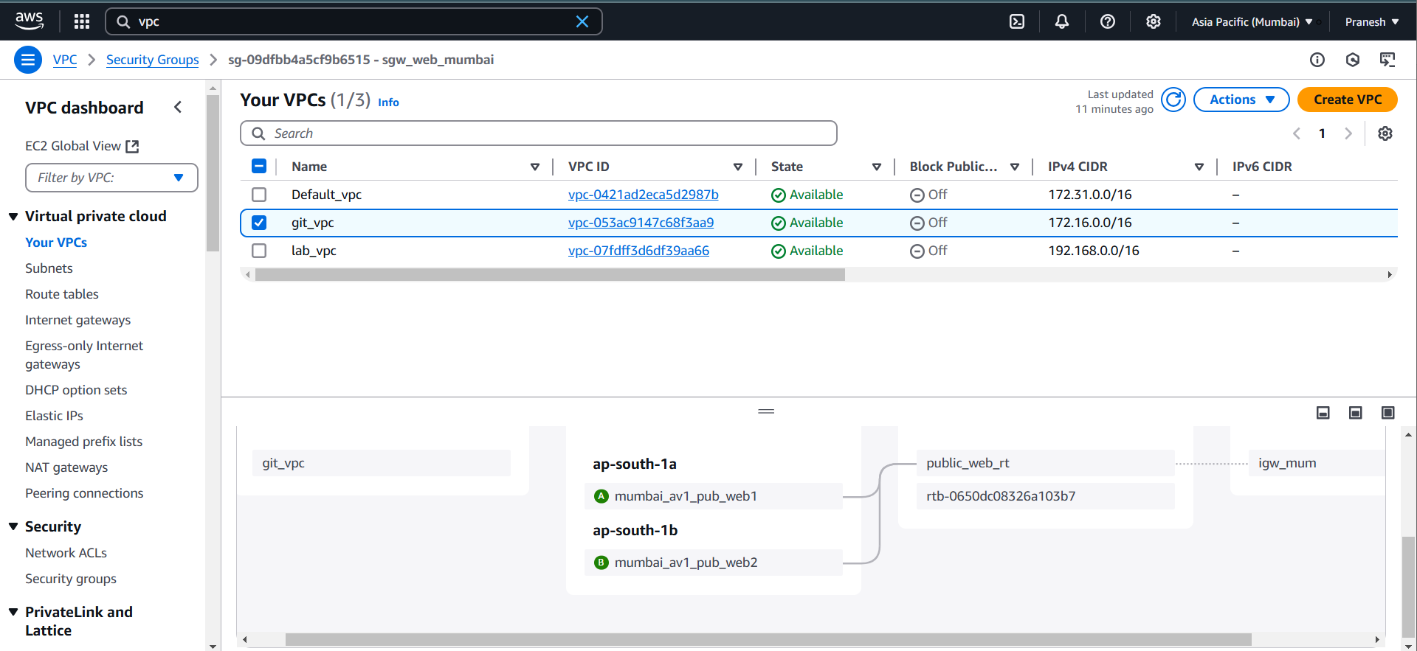

SINGAPORE:

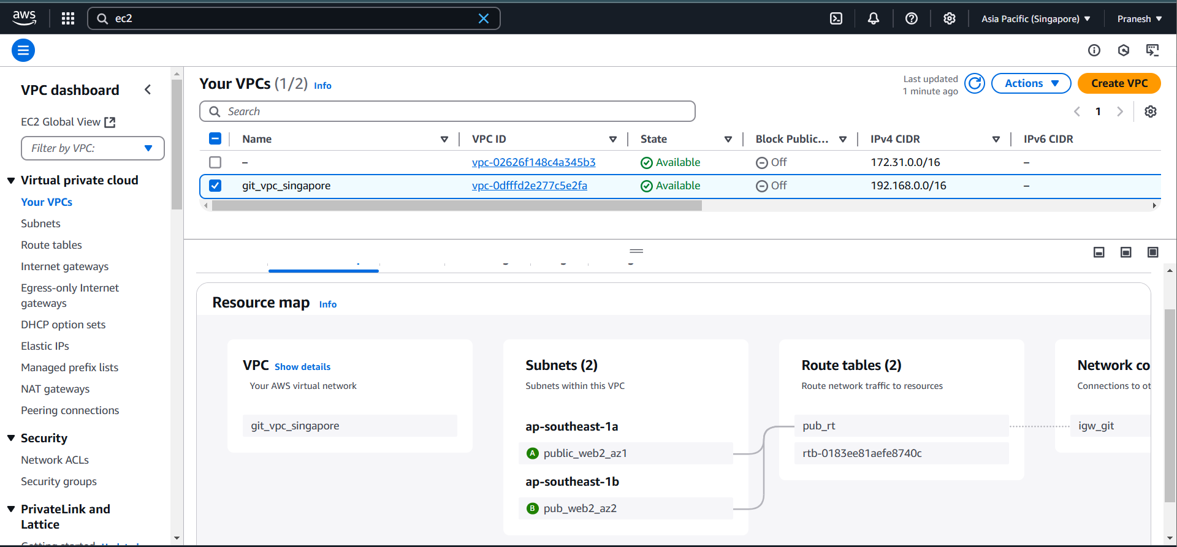

Create an instance to push the created repo to git hub:

1. yum install git

add the git hub account

1. git config –global user.name “<username>”
2. git config –global user.mail “<mail>”

Generate and share the ssh key

1. ssh-keygen -t rsa -b 4096 -C “comment”
2. eval “$(ssh-agent -s)” – adding ssh-agent in bg
3. ssh-add <private key path> -- to add the priv key to ssh-agent to avoid key auth everytime.
4. Copy the public key add to github account in SSH-GPG

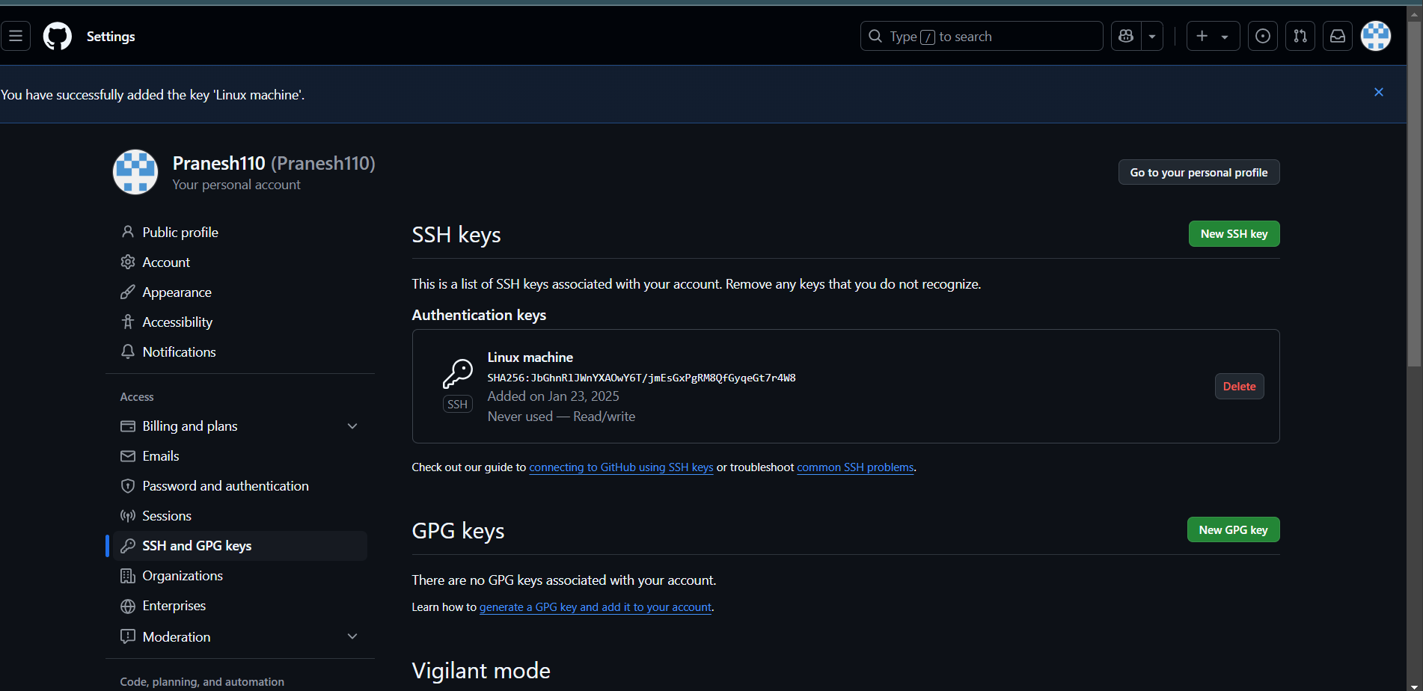

Create a repo :

1. make directory—mkdir name
2. cd to the dir
3. to initialize .git file for the repo—git init
4. ADD the webpage file to the repo
5. git add . – to stage the change
6. git commit – to commit the change
7. Create a repo in git hub and copy the ssh
8. Remote add – git remote add origin ssh-url
9. Push the repo to git hub—git push -u origin main/master

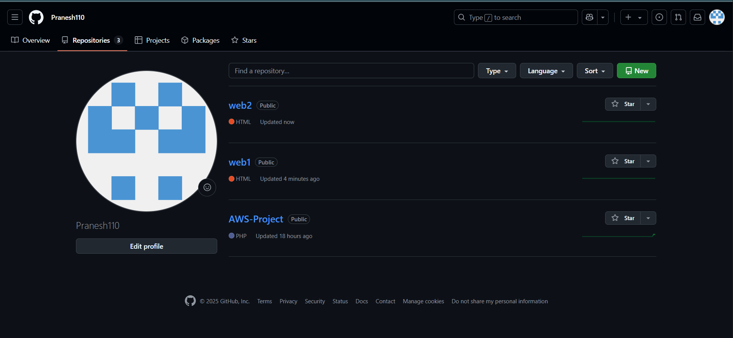

Create two instance on two diff region and add Load balancer to the instance:

SINGAPORE:

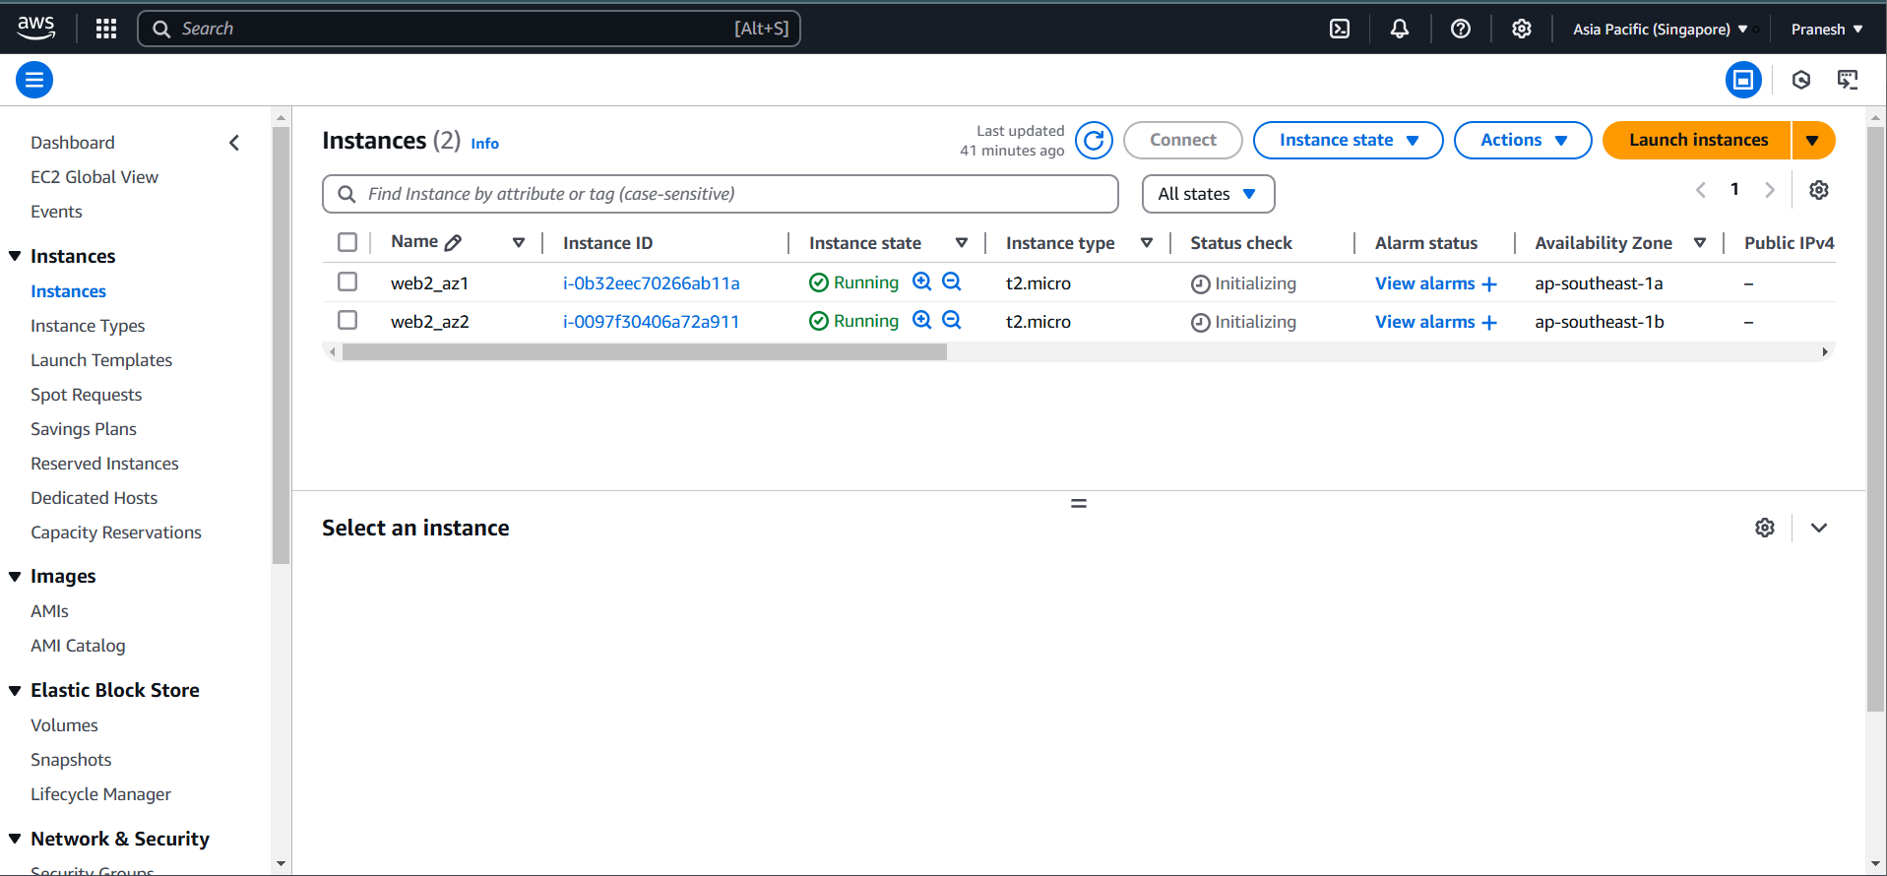

MUMBAI:

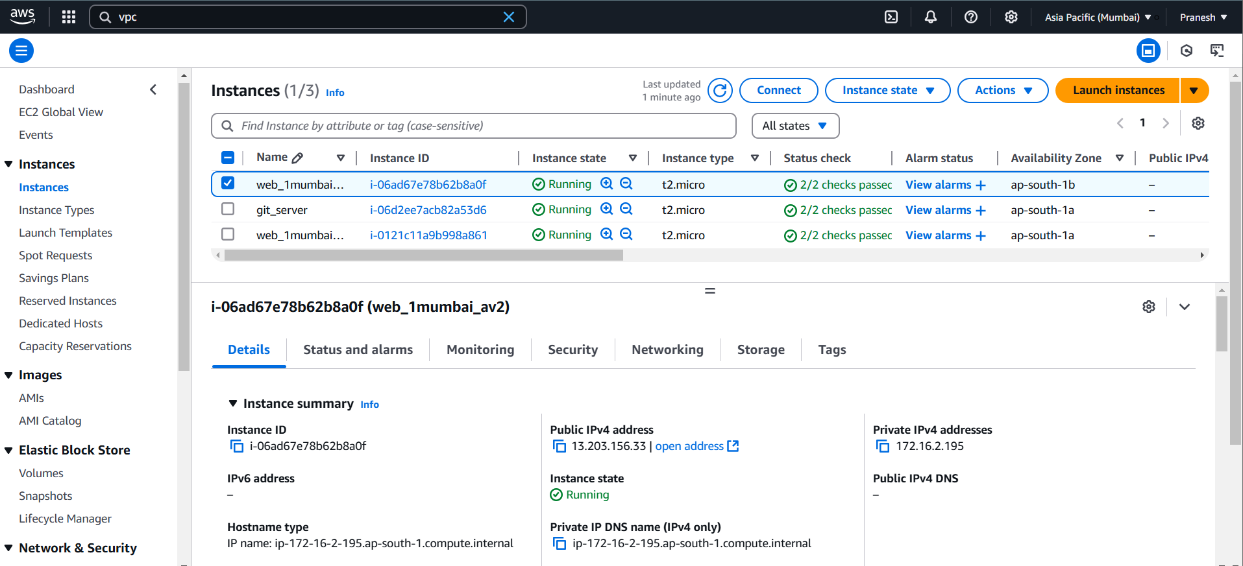

Install the git and web server (apache) package:

Yum install git httpd -y

Start the service – systemctl start/enable httpd on the 4 instances

**Configure the git on the 4 instance and clone the web1 repo to Mumbai region instance and web2 repo to Singapore region instances.**

**MUMBAI:**



**SINGAPORE:**



**NOW** add the LOAD BALANCER to the instance on both region:

Create a load balancer on two region and add instance:

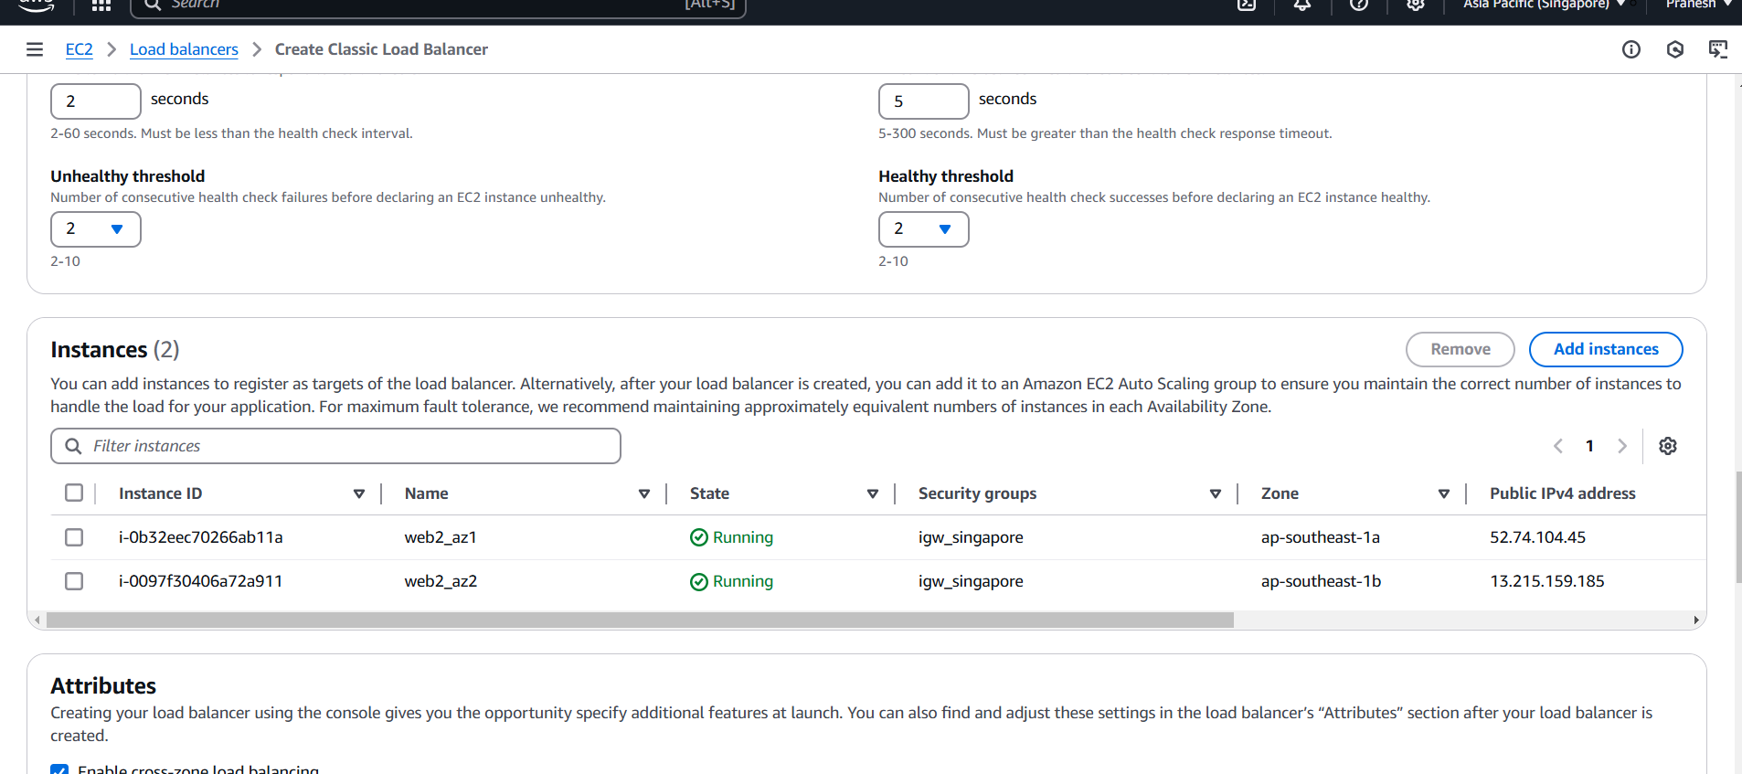

Check the instance are healthy after attached:

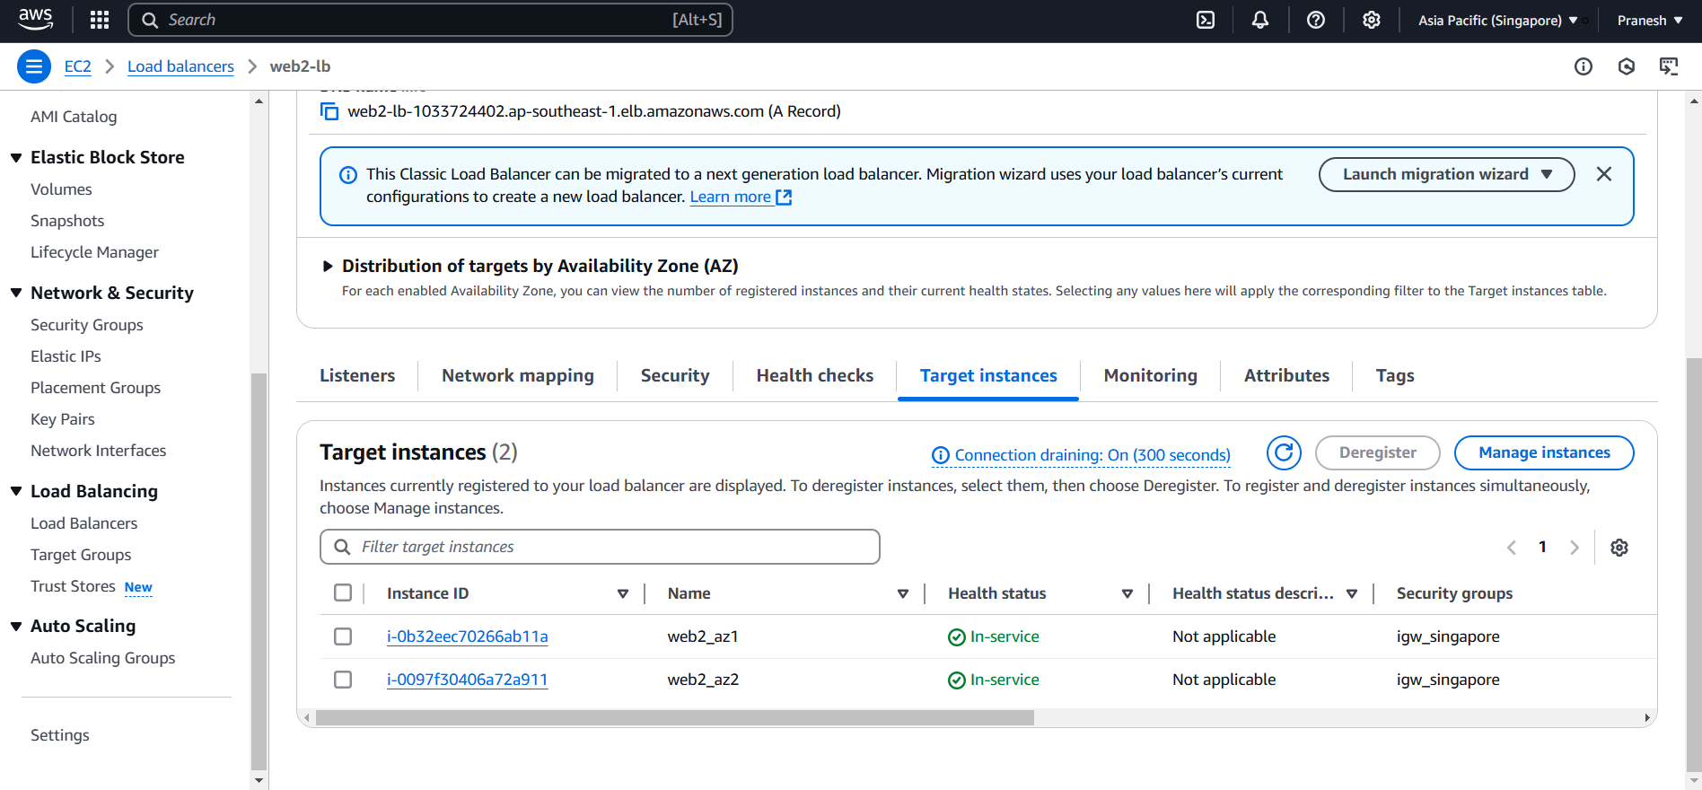

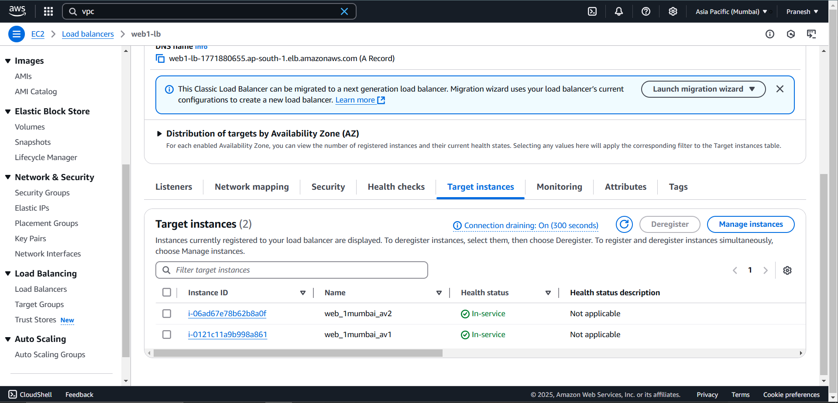

Ping the Load balancer DNS of lb on both region :

MUMBAI region LB:





SINGAPORE REGION LB:





YOU CAN SEE HIT ARE EVENLY DISTRIBUTE!!